**Lesson 1 Demo 8**

**Access Chaincode Functions**

|  |
| --- |
| **Objective:** To access chaincode functions  **Tools required:** Ubuntu  **Prerequisites:** Lesson 1 Demo 7 |

Steps to be followed:

1. Accessing the chaincode functions from Org1

**Step 1: Accessing the chaincode functions from Org1**

1. Invoke the **Init** function using the following command:

***eer chaincode invoke -o localhost:7050 --ordererTLSHostnameOverride orderer.example.com --tls $CORE_PEER_TLS_ENABLED --cafile $ORDERER_CA -C mychannel -n CrossBorderPayment --peerAddresses localhost:7051 --tlsRootCertFiles $CORE_PEER_TLS_ROOTCERT_FILE_ORG1 --peerAddresses localhost:9051 --tlsRootCertFiles $CORE_PEER_TLS_ROOTCERT_FILE_ORG2 --isInit -c '{"Args":[]}'***

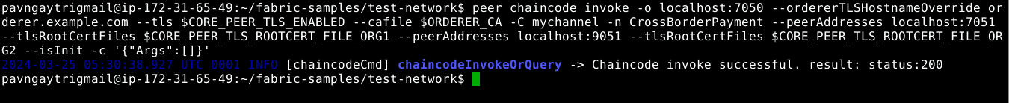

1. Invoke the **addNewLetterOfCreditIssue** function using the following command:

***peer chaincode invoke -o localhost:7050 --ordererTLSHostnameOverride orderer.example.com --tls $CORE_PEER_TLS_ENABLED --cafile $ORDERER_CA -C mychannel -n CrossBorderPayment --peerAddresses localhost:7051 --tlsRootCertFiles $CORE_PEER_TLS_ROOTCERT_FILE_ORG1 --peerAddresses localhost:9051 --tlsRootCertFiles $CORE_PEER_TLS_ROOTCERT_FILE_ORG2 -c '{"Args":["addNewLetterOfCreditIssue", "6", "25thApril2024", "JorgMelton_SINGAPOREANbuyer_Dryfruits", "INTERNATIONAL_TRADE_BANK", "VikranthSinha_INDIANseller_Dryfruits", "80,000$", "issued"]}'***

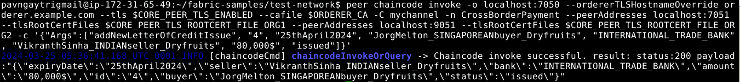

1. Invoke the **change LetterOfCreditIssueOwnership from Buyer To Seller** function using the following command:

***peer chaincode invoke -o localhost:7050 --ordererTLSHostnameOverride orderer.example.com --tls $CORE_PEER_TLS_ENABLED --cafile $ORDERER_CA -C mychannel -n CrossBorderPayment --peerAddresses localhost:7051 --tlsRootCertFiles $CORE_PEER_TLS_ROOTCERT_FILE_ORG1 --peerAddresses localhost:9051 --tlsRootCertFiles $CORE_PEER_TLS_ROOTCERT_FILE_ORG2 -c '{"Args":["changeLetterOfCreditIssueOwnership", "4", "25thApril2024", "JorgMelton_SINGAPOREANbuyer_Dryfruits", "INTERNATIONAL_TRADE_BANK", "VikranthSinha_INDIANseller_Dryfruits", "80,000$", "accepted"]}'***

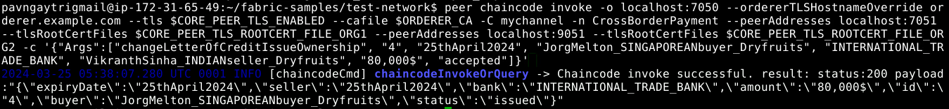

1. Invoke the **queryLetterOfCreditIssueById** function using the following command:

***peer chaincode invoke -o localhost:7050 --ordererTLSHostnameOverride orderer.example.com --tls $CORE_PEER_TLS_ENABLED --cafile $ORDERER_CA -C mychannel -n CrossBorderPayment --peerAddresses localhost:7051 --tlsRootCertFiles $CORE_PEER_TLS_ROOTCERT_FILE_ORG1 --peerAddresses localhost:9051 --tlsRootCertFiles $CORE_PEER_TLS_ROOTCERT_FILE_ORG2 -c '{"Args":["queryLetterOfCreditIssueById", "4"]}'***

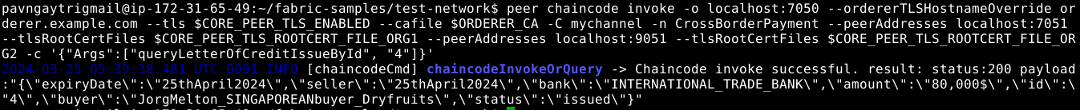

The chaincode functions is now accessed from Org1.